Ideas for Supporting your Child with Handwriting and Letter Formation
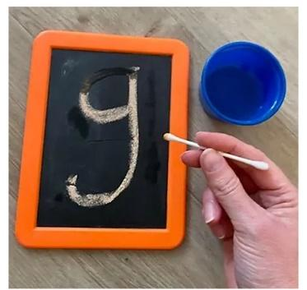
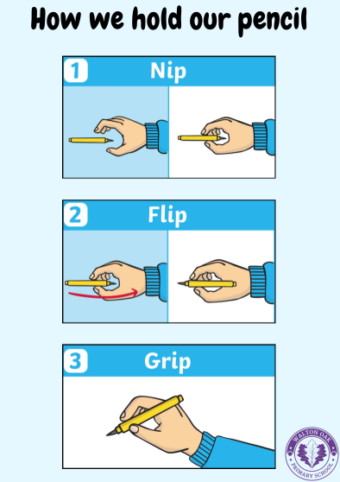
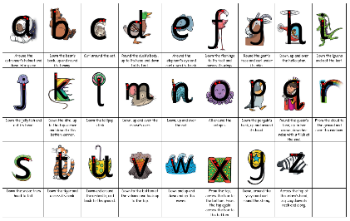
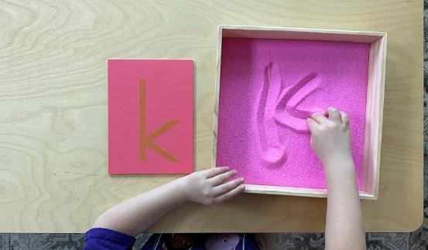

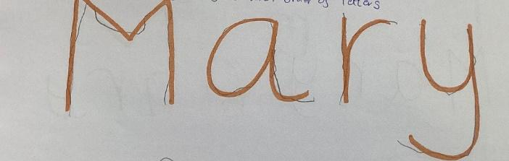
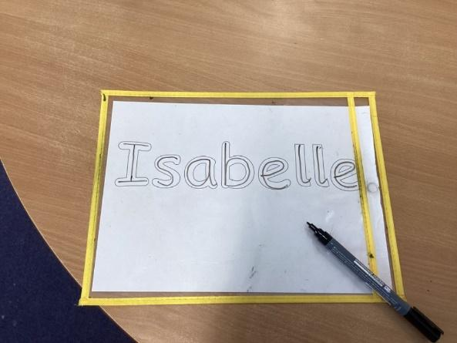
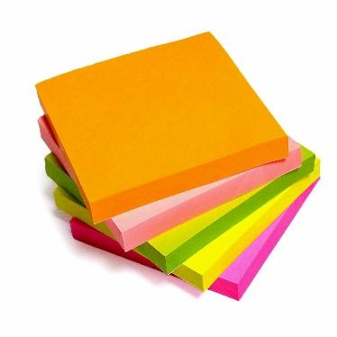
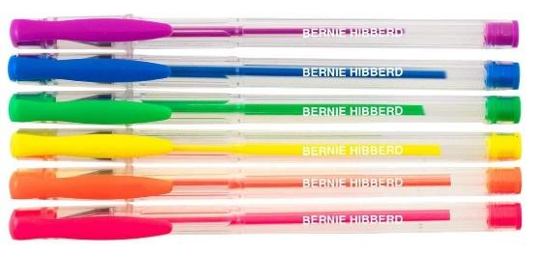
Tracing letters using cotton buds
Encourage correct pencil grip
Letter formation in sand, rice, lentils, flour etc.
Write letter in felt tip pens for your child to trace.
Write shapes or letters with them using hand over hand.
Create bubble writing letters for your child to trace.
Give your child different pens or paper to encourage motivation to practise writing
Always use Little Wandle rhymes to support letter formation.

